Logging onto SCOOTLE

What is Scootle?
Scootle (www.scootle.edu.au) contains access to more than 7800 items of digital curriculum content from The Le@rning Federation. Scootle provides ways to find, organise and use this material.
TLF’s digital content includes:
- learning objects: interactive, multimedia resources designed for Australian and New Zealand curricula
- digital resources: items sourced from Australia and New Zealand's premier cultural institutions that may be a section of moving image footage; an image of a document, line drawing, painting, or map; a photograph; an audio file of a song or broadcast
- teaching and assessment resources: assessment objects, teaching notes and assessment ideas to support the digital curriculum content.

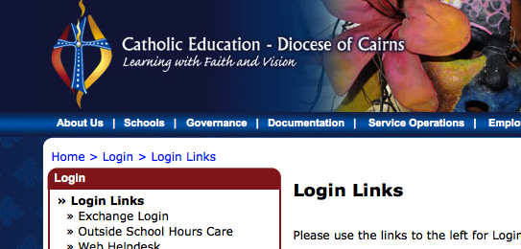
STEP ONE

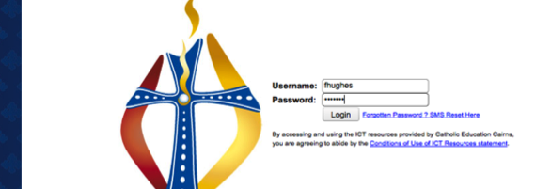
STEP TWO

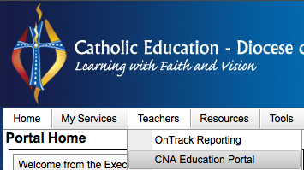

STEP THREE

STEP FOUR:
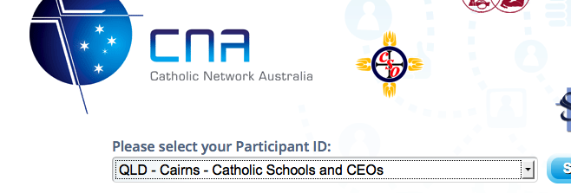
Select participant ID and click Sign in

STEP FIVE
Complete sign in. Click submit.
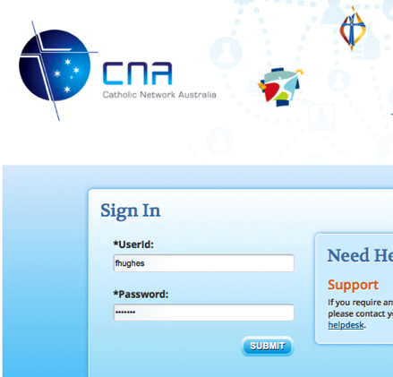

STEP SIX:

STEP SEVEN
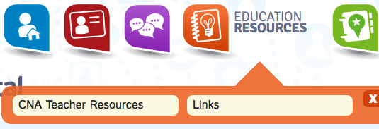

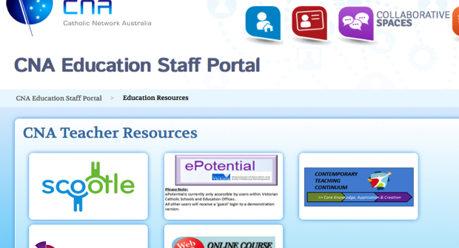
STEP EIGHT

STEP NINE: Start using SCOOTLE

